

**Will UK investment bounce back?**

Speech given by

Jonathan Haskel, External Member of the Monetary Policy Committee

University of Birmingham 11 March 2019

I am immensely grateful to Srdan Tatomir and Jamie Lenney for their invaluable comments and assistance with the speech. My thanks also go to Sandra Batten, James Bell, Ben Broadbent, Alan Castle, Clare Cowan, Jon Cunliffe, Mike Goldby, Clare Macallan, Marko Melolinna,

Darren Morgan, Michael Saunders, Michal Stelmach, Matt Swannell, Jan Vlieghe, and Stian Westlake for very helpful suggestions. Errors and opinions are my own.

Good afternoon.

Thank you all for coming today. It is an honour for me to be here at the University of Birmingham. I am pleased to be renewing the connection that I made with the University over the years that I was an external examiner here in the Economics Department working with Ralf Bailey who ran the exams process with such care and attention. Thousands of students don’t know it but they owe a huge debt of gratitude to him.

I come here not as an external examiner but as an external member of the UK Monetary Policy Committee, having joined the Committee in September last year. For those of you who don’t know, external members are accountable in a formal sense through direct reporting to Parliament, but in an informal sense through public appearances and making speeches to explain their thinking and votes on interest rates. Actually, this is my first speech as a member, so it’s a double honour to be back here and to be invited by Professor Peter Sinclair whose work for the Bank is so valuable.

Today I will focus on the role of UK business investment. There are three broad points I would like to make. First, as has been widely noted, UK investment has been very weak in the last couple of years, especially during the last year, see for example speeches by (Carney, 2019) and (Vlieghe, 2019) suggesting that Brexit uncertainty is weighing on business investment. Second, looking at the assets that make up investment reveals some interesting patterns: transport equipment has been particularly weak, but intellectual property products (R&D, software, artistic originals) were somewhat stronger. Third, regarding Brexit, as Sir Ivan Rogers, the UK’s former representative to the EU, has said (Rogers, 2018), “Brexit is a process not an event”. That process has the possibility of creating more cliff-edges; the length of the transitional/implementation period, for example. Since the very nature of investment is that it needs payback over a period of time there is a risk that prolonged uncertainty around the Brexit process might continue to weigh down on investment.

# Background

* 1. *What is investment?1*

“Investment”, “assets” and “capital” can be confusing terms. Financial journalists typically refer to people who buy and sell stocks and shares as “investors” and try to describe and justify the “mood of investors”. Other commentators call long-termist share-buyers like Warren Buffett an “investor” and his short-termist rivals a “speculator”. Your parents might have advised you that “going to university is the best investment you can make”.

1 This discussion follows (Haskel & Westlake, 2018)

Matters get even more confusing when we come to “capital”. Accountants talk about “working capital” when they describe what others call cash. Piketty’s book (Piketty, 2014) defined capital as any form of wealth (“all forms of wealth that individuals… can own”). Scholars are still arguing about what Marx meant by “capital” (he talked about fixed and circulating capital, sometimes referring to machines and sometimes to labour, sometimes stocks and sometimes flows).

So let’s try to be clearer by going to internationally recognised definitions. The OECD defines investment (actually gross fixed capital formation) as “net acquisition of produced fixed assets” (OECD, 2014). How does that help us?

The definition covers a “produced asset”. An asset is an economic resource that is expected to provide a benefit over a period of time e.g. a computer or building or software programme, rather than paying the electricity bill. A produced asset results from using up resources in the process of production: producing a plane or doing R&D. This immediately excludes a “financial” asset, since that’s just a piece of paper. So, spending on a stock or share or savings bond is not investment in these terms. It does buy you an asset (e.g. a share that pays dividends over time) but it is not spending on a produced asset. Furthermore, the use of produced assets restricts attention to where production is recognised in the national accounts. A non- produced asset is land, forest and minerals, for example. In addition, national accounts measure production by firms or government or the third sector2. If a restaurant buys a dishwasher machine it is investing. If you or I buy a dishwasher to use at home, we are not investing since households are not assumed to be producing (investment in new domestic housing is an exception here - see below3). Finally, fixed assets exclude inventories.

In this speech then, we are not going to look at investment as buying financial assets, or domestic spending such as cars, dishwashers and university fees. Rather, we will focus on spending by business, government or the third sector that creates a long-lived stream of productive services4.

* 1. *A first look at investment*

To fix ideas, **Table 1** contains nominal investment5 in the UK for 2018. As the top line sets out, it was close to £360bn. Remembering that nominal GDP is £2.1 trillion, this is around 17% of GDP. That is to say, that of £100 of GDP, every year the economy puts aside around £17 to invest for the future.

2 The third sector refers to non-governmental and non-profit-making organisations including charities, voluntary and community groups, cooperatives, etc.

3 The exclusion from GDP of household activities such as housework, child care etc. is of course highly controversial, not least since it excludes from GDP a very large part of the economy where tasks have historically been performed primarily by women, see (Coyle, 2015).

4 The fixed asset that provided these long-lived productive services, an aircraft, computer or building we shall call “capital”. Capital as wealth is their asset value i.e. the value of such assets if they were sold as a whole. Capital as providing capital services are proportional to their rental values.

5 In national accounts the term gross fixed capital formation is used.

The rows then parse out the components of investment, beginning with housing investment. At first sight, this would seem not to belong: isn’t this a household spend, like a dishwasher, that we just excluded? This then is an illustration of the point that the boundaries of GDP are actually rather porous: housing is such a big-ticket item that national accountants include it as investment. We shall, in this speech, focus on business investment and so exclude it from now on6.

Business investment is decomposed into buildings, plant and machinery (including ICT goods), transport equipment and intellectual property products. Over time, investment in intellectual property products (IPP) has been steadily growing and this is where the “knowledge economy” sits, for IPP consists of investment in software, artistic originals and R&D. Thus, it is the category that is perhaps the hardest to measure (how much is investment in a Harry Potter movie or new software for Game of Thrones?), but over the long term is growing in share: on all this, see (Haskel & Westlake, 2018).

# Table 1 – Gross fixed capital formation in the United Kingdom in 2018 by institutional sector and asset type

6 Household investment in dwellings excludes the value of land, since land is viewed, in the UK national accounts, as a non-produced asset, see above.

* 1. *Why investment matters*

For a monetary policy maker investment is doubly important because of its role on both the supply and demand side. The supply side role follows directly from the discussion above. Investment builds capital assets that provide productive services (“capital deepening” is the growth in those capital services per hour worked over time). Such capital deepening, over long periods, typically accounts for over 50% of productivity growth in the UK (the rest being, in a sense to be defined later, the efficacy of use of those services).

At the same time, gross domestic product is defined as the sum of the value of consumption, investment, government expenditure and demand for net exports. Despite business investment being a small share of GDP of around 9% it is a highly variable component7 which is illustrated in **Figure 1**.

# Figure 1 – The volatility of business investment relative to household consumption and GDP

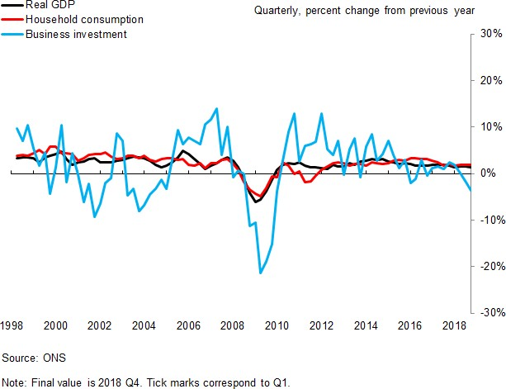

Now, since a monetary policymaker is concerned primarily with inflation, how does investment matter specifically?

The point is that investment affects both aggregate demand and aggregate supply. When investment in the economy grows this increases demand for goods and services used to invest. For example, when a company buys computers and software it directly spends money to acquire them. All else equal, that exerts

7 For example, business investment is around 3.5 times more variable than household consumption. This compares the standard deviation of annual growth of business investment to household consumption over the period 1998-2018.

upward inflationary pressure. But, what happens once those computers and software are installed and up and running? Once that occurs then the company's productive capacity increases and it can supply more of its products to consumers. All else equal, this increases aggregate supply and exerts downward inflationary pressure. With this in mind, let me turn to the data and recent trends in business investment.

# Recent trends in business investment

* 1. *UK top line business investment*

With this as background, **Figure 2a** shows real UK business investment since 1998 (the black line, ignore the other lines for the moment). The figure shows the stark fall in business investment during the great recession, a slow recovery that appeared to have gathered momentum in 2014 and 2015 but has tailed off in the most recent years, starting in 2016, with a noticeable dip in 20188.

# Figure 2a – The level of business investment in the United Kingdom since 1998

Business investment

£ billions (CVM, 2016)

55

Avg. growth rate (1998-2007)

Avg. ratio to GDP (1998-2007)

50

45

40

35

30

1998 1999 2000 2001 2002 2003 2004 2005 2006 2007 2008 2009 2010 2011 2012 2013 2014 2015 2016 2017 2018

Source: ONS and Bank calculations.

Note: The red dotted line grows out real business investment in 2008 Q1 in line with it s average quarterly growth rate of 0.5 percent realised over the period 1998-2007. The blue dashed line is 9.7 percent of realised GDP, where 9.7 percent is the average ratio of real business investment to real GDP between 1998 and 2007.

The last datapoint is for 2018 Q4. Ticks marks along the horizontel axis correspond to Q1.

This figure suggests visually that investment has been weak in recent years. To be more precise we really need to measure investment relative to some counterfactual. **Figure 2a** shows two. The first is the continuation of the 1998-2007 trend and the second is the average I/Y ratio 1998-07 (for students of

8 In two speeches in 2014 my colleagues (Broadbent, The balance of growth, 2014) and (McCafferty, 2014) asked why the recovery in investment had been so weak. That question was asked relative to consumption growth which had been relatively strong. It is also the case that the path of investment was weaker relative to the path following previous downturns. This is shown in Chart 2.3 on page 10 of the February 2019 *Inflation Report*.

economics, that second line is an assumption made by Solow, namely that I=sY). Both show investment weakness. **Figure 2b** shows another possible counterfactual, namely UK business investment growth against a swathe showing the maximum and minimum of non-UK G7 business investment for each year. This illustrates that the UK has fallen away from its peers with whom they normally co-move.

# Figure 2b – UK business investment relative to other G7 countries

Annual % change

G7 ex. UK

UK

  

Source: Datastream from Refinitiv.

Note: The last value displayed is for 2018 Q3. Tick marks along the horizontal axis correspond to Q1.

20

15

10

5

0

-5

-10

-15

-20

-25

-30

One feature of investment data is that it gets revised. The standard deviation around the difference between when a calendar year’s investment growth is first reported and the revised figure reported one year later is about four percentage points9. Recent methodological improvements, however, should have brought this figure down. For example, there are some well-known biases in data collection whereby firms that respond to the ONS survey later report higher capital expenditure, which are being corrected for. In addition, the ONS survey sample size has risen by 10% and response rates have improved now that the entire survey is online. So, we can place more weight on the weak business investment numbers than we might have at this stage in the past. Indeed, this has been the case for the quarter to quarter revisions since 2016 Q110.

* 1. *Exploring the investment decline*

We’ve looked at the picture for total UK business investment. As we have seen however, investment consists of many asset types which might potentially behave very differently. Do we learn anything new from looking at these?

9 Based on ONS revisions triangles over the period 1998-2018.

10 The average absolute revision has fallen from 1.1 percentage points over the period 1998-2015 to 0.4 percentage points over the period 2016-2018.

**Table 2** shows average growth rates over different periods of business investment11, and its subcomponents, with the final columns showing data post-EU referendum and for 2018. There are three key points. First, transport equipment is very volatile with a strong fall after the referendum. Second, the final row excludes transport equipment and shows a fall post-referendum but not as much as before. Third, IPP investment has held up relative to plant and transport. We look at these in turn.

# Table 2 - Decomposition of business investment in the United Kingdom by asset type

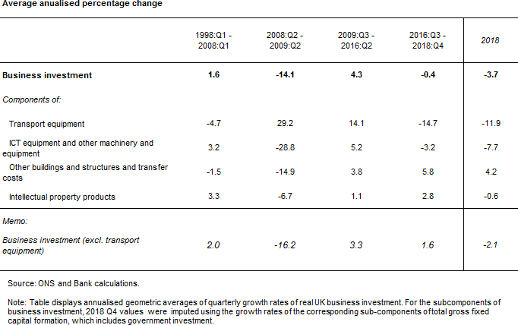

* 1. *Transport equipment*

Beginning with transport, **Figure 3** shows the contributions of the asset types that we saw in Table 1 to overall quarterly investment growth since 2016Q3. As it shows, the weakness in business investment in 2018 was concentrated in transport equipment in Q2 and Q3, but in machinery in Q1 and Q4.

We can then look at just the transport industry, and decompose business investment by various transport industries. This is shown by **Figure 4** which suggests most of the fall in transport industry investment can be accounted for by the air transport industry although this is the most volatile component.

11 Business investment estimates exclude expenditure on dwellings and the costs associated with the transfer of ownership of non- produced assets, and capital expenditure by local and central government.

**Figure 5** looks at transport investment by documenting the ratio of investment to the capital stock. Since capital depreciates we would expect that at least some investment would have to cover such depreciation. Depreciation rates in transport equipment are typically between 10% (buses, trains, ships) and 30% (trailers) so just replacement would give an average I/K ratio of around 20%. As the figure shows, there was big growth in 2014, and decline in 2016.

What then do we conclude from all this? First, investment in transport equipment has been, over the past four years quite erratic, and contributed strongly to the 2018 fall. Second, the current I/K ratio does not look out of line with historic averages suggesting that a sustained bounce back from this asset class is not likely.

|  |  |
| --- | --- |
| **Figure 3 – Contributions to changes in real business investment growth by type of asset** | **Figure 4 – Business investment by transport industry** |
|  | Other Warehousing £ million  Land transport Air transport 18000  Total  16000  14000  12000  10000  8000  6000  4000  2000  0    Source: ONS  Note: This graph decomposes nominal investment by the transport industry  (industry code 29 and 30) into its sub-industries. The other category consists of investment by water transport and postal/courier industries. |

# Figure 5 – Investment in transport equipment relative to its productive capital stock

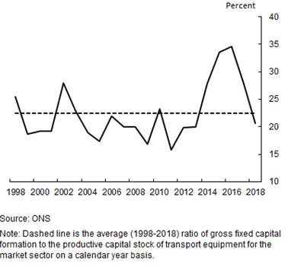

* 1. *IPP*

There is some indication from the bottom row of the top panel of **Table 2** that investment in IPP has held up somewhat, at least relative to other categories. We have data up to 2018 on the software and R&D subcomponents of IPP and that indicates that both have continued to grow (that said, wider measures of knowledge investment, such a training, have dipped, see (ONS, 2019) for example). What can we conclude from this? One point about much IPP investment is that it crosses borders easily: that is, R&D investment in country X can likely be rolled out to country Y more easily than can a plant. Thus, one might regard IPP investment as a counterfactual against which to judge Brexit: if IPP investment is not subject to border problems, it should be unaffected by goods tariffs and hence by (at least that dimension of) Brexit. Under that view, the relative decline in tangible investment suggests Brexit is weighing on investment. A related view is that much intellectual property investment is instantiated in people and hence IPP investment moves more slowly than plant again suggesting downward weight from Brexit.

* 1. *Overall*

To summarise this, **Figure 6** shows UK real investment growth against G7 countries, for all investment, excluding transport, (**Figure 7**) and IPP, (**Figure 8**). As can be seen, the poor relative investment picture is there, but in less stark terms if we exclude transport equipment, and the UK is holding its own in the case of IPP.

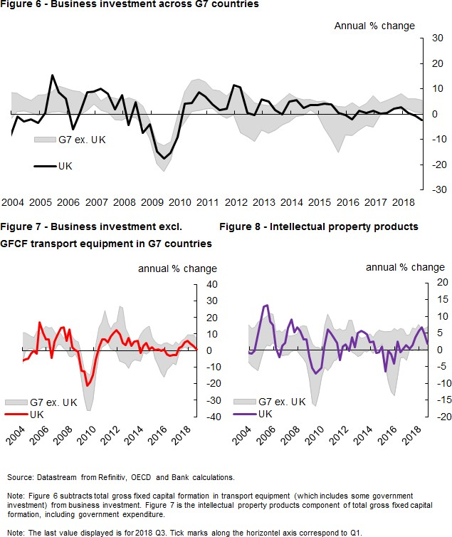

# Causes of low investment

We turn now to exploring some the possible causes of low investment. The first thing an economist would look at is the price of investment, for if the price of something is high then the demand for it is low, all else equal. This route turns out to be rather complicated for the following reasons.

First, the price of investment is not a straightforward notion. The website [www.avibroker.com](http://www.avibroker.com/) is currently offering a 1998 Boeing 737-300 airliner for sale outright at $18m or yearly (dry) lease for just over $1m. By the definitions above, a plane is an investment so which of these is the “price” of that investment? The answer is that they are both prices, but of different things. The $18m is an “asset price”, that is, the price to buy the entire asset and so use it over a number of years. The $1m is a rental price or user cost, that is, the

price of using the asset but just for one year. The relation between these prices is set out in (Jorgenson & Griliches, 1966).

Second, since an investment *by definition* lasts for a number of years, the returns have to be forecasted over a number of years. In some cases, that uncertainty is captured in the price or uncertainty is something that can be protected against: buildings owners can buy insurance against fire, for example. In other cases uncertainty can at least be estimated with some reasonable degree of precision: the probability of a winning lottery ticket, for example.

But the current uncertainty facing firms seems different; perhaps not amenable to applying probabilities. Regarding Brexit, we have never left the EU before. This class of uncertainty is called in economics “Knightian” uncertainty (after a 1921 book by Professor Frank Knight, called *Risk, Uncertainty and Profit*) and was emphasised by (King, 2016)*.* Like many phenomena it was explained in a remarkably prescient 1939 essay by Keynes who described the term “uncertain knowledge” as follows:

“*… The sense in which I am using the term is that in which the prospect of a European war is uncertain, or the price of copper and the rate of interest twenty years hence, or the obsolescence of a new invention, or the position of private wealth-owners in the social system in 1970. About these matters there is no scientific basis on which to form any calculable probability whatever. We simply do not know.*”

This seems to describe the Brexit process rather well. Third, at least some investment is irreversible in that it cannot be recovered once committed, giving rise to what economists call a sunk cost. Much IPP type- investment is of this type: Microsoft had to write off $5bn when their Windows Mobile program, that powered Nokia mobile phones, was retired. Thus, uncertainty matters here too, since the very decision to postpone a reversible investment represents something of value, namely the possibility of committing the investment at a later date12.

So what evidence do we have on these matters?

* 1. *Cost of capital and capital returns.*

Starting with prices, **Figure 9** sets out various measures of the costs and returns to capital. The net rate of return is calculated as UK non-financial corporations' net operating surplus/net capital stock (per annum)13. The average cost of loans is based on the weighted average interest rate of sterling loans made to private non-financial corporations by UK resident monetary financial institutions (excl. the central bank). Finally, the weighted average cost of capital (WACC) reflects the cost of those bank loans, the cost of bond financing

12 As (Broadbent, Uncertain times, 2016) has pointed out, the option value of waiting can rise very fast as uncertainty increases. See pp 3-5 in (Broadbent, Uncertain times, 2016) for a discussion.

13 Matters are somewhat complicated here depending on whether activities on the UK Continental Shelf are included or not since their rate of return is rather volatile: they are excluded here.

and equity financing. There is considerable uncertainty around the WACC as the part of the cost of equity finance, the equity risk premium, has to be estimated.

As **Figure 9** shows, the cost of finance has remained low relative to historical averages. That said, there appears to have been a slight rise in the most recent years and a fall in the net rate of return. It seems unlikely that investment has fallen so much due to these recent rising capital costs.

# Figure 9 – ONS net rate of return and the cost of finance for UK private non-financial corporations

Net rate of return for all UK PNFCs (ONS) (a)

Average cost of loans for private non-financial corporations (b) Weighted average cost of capital (c)

Bank Rate Per cent

16

14

12

10

8

6

4

2

0

2000 2002 2004 2006 2008 2010 2012 2014 2016 2018

Source: Bank of England, ONS *Profitability of UK companies, Refinitiv.*

* + 1. UK non-financial corporations' net operating surplus/net capital stock (per annum).
    2. Weighted average interest rate of sterling loans made to private non-

financial corporations by UK resident monetary financial institutions (excl. the central bank).

* + 1. This is partly based on estimates of the equity risk premium as described in Dison and Rattan (2017). There is considerable uncertainty surrounding these estimates.

One element of investment costs for firms is the tax system. In recent years the UK has been quite aggressive in offering tax breaks to firms on various investment types particularly for R&D. The overall effect on the (rental) cost of capital interacts with the corporate tax system in various ways and so the full calculation of the stance is complicated but the OECD has developed various measures of tax and other support for R&D which are summarised for 2016, the most recent year available, in **Figure 10**. As the figure shows, subsidies for R&D come in various ways via tax support and direct funding on e.g. challenge projects. The UK is towards the more generous countries but note that generosity has increased in many countries since 2006 (compare the black dots which are generally below the top of the stacked bars) and so the UK is in competition with these countries.

# Figure 10 – OECD R&D subsidies by type

* 1. *Uncertainty*

Bank of England staff monitor uncertainty using a range of measures as outlined in a Quarterly Bulletin article in 2013 (Haddow, Hare, Hooley, & Shakir, 2013). The different indicators shown in Figure 11 capture different aspects of uncertainty. The measures included are the three month option implied FTSE volatility, three month option implied sterling ERI volatility, the dispersion of consensus GDP forecasts, GFK unemployment expectations, GFK expectations of the financial situation over the next 12 months, CBI demand uncertainty, media citations of uncertainty, and the standard deviation of analysts’ forecasts of 12 month-ahead company earnings growth for the FTSE All Share. But no single measure captures uncertainty perfectly. Some, like the GfK unemployment expectations balance, are more likely to capture changes in expected average output growth rather than the variation in those growth rates. Others measure perceived uncertainty either by directly asking firms or monitoring media references. Figure 11 doesn’t immediately suggest that UK uncertainty has been elevated over the past year. One possibility is that it doesn’t capture the kind of Knightian uncertainty mentioned above. That is, companies might feel so uncertain that they might just carry on as normal (for reversible decisions like hiring, for example) since they don’t know how else to react. In this regard, one other method is to ask firms directly what they are worrying about. That is exactly what the joint Bank of England and University of Nottingham Decision Makers’ Panel survey has done and the answer is set out in Figure 12. That shows that towards the end of 2018 that around half of firms that have responded cite Brexit as one of their top 3 current sources of uncertainty.

# Figure 11 – Measures of uncertainty in the United Kingdom

Standard deviations from mean

5

4

3

2

1

0

-1

-2

-3

-4

-5

2005 2007 2009 2011 2013 2015 2017

FTSE volatility Weighted ER vols Consensus GDP forecasts GfK unemployment expectations GfK financial situation next 12 months CBI demand uncertainty Media citations Company earnings

# Figure 12 – Decision Makers’ Panel survey: firms and Brexit-related uncertainty

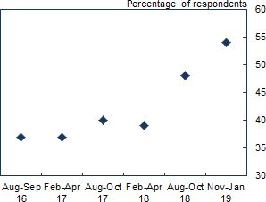

Source: DMP Survey and Bank calculations.

(a) Question: ‘How much has the result of the EU referendum affected the level of uncertainty affecting your business?’. Results show the percentage of respondents that place the EU referendum in their top three sources during the survey period.

* 1. *Summary: Why has investment been so low?*

To judge just how much Brexit uncertainty has weighed on investment is difficult. In the absence of a perfect counterfactual or model I return to **Figure 2b** where UK investment is compared to our G7 peers14. Assuming UK business investment grew at the same rate (2.9 percent, excluding the UK) as the median G7 country

14 To gauge the impact of Brexit, Vlieghe (2019) has used the synthetic ‘doppelganger’ approach to create synthetic and counterfactual UK GDP growth. He finds that relative to June 2016, UK GDP is 2% is lower relative to a scenario where there were no significant domestic political events.

since 2016Q2, investment growth would be only 1.5 percent weaker than the average of the post-recession period up until the referendum. Recall (**Table 2**) that in that period UK investment grew by annual average of

4.3 percent but post referendum the growth rate has averaged -0.4 percent. This suggests that of the 5pp fall in the growth rate, 3.5pp could be accounted for by Brexit, almost 70 percent of the slowdown. This is broadly true even if we exclude all investment in transport equipment15.

# Investment and productivity

As we said above, investment has an effect on the supply side of the economy by deepening the capital services available to the economy. We have already suggested that production comes from capital services and so this section looks at the link between investment, capital services and productivity.

* 1. *Investment and capital services*

Consider first tangible investment. Think of a supermarket: the building, shelves and checkout tills and trucks. All these together provide capital services that, combined with labour and the items in the shop, become sales. (Jorgenson & Griliches, 1966) proposed to calculate capital services in two main steps. First, they constructed capital stocks from the investment data by treating real investment as an addition to the capital stock and subtracting depreciation. Second, they added together the capital stocks i.e. building, equipment and vehicle stocks by weighting them by their rental values, reasoning that such values were the market’s way of valuing the contribution (at the margin) of each asset type to total capital services. One effect of doing this is to “smooth out“ the volatilities in investment. After all, if a supermarket doesn’t build any new stores in a year, it still has many existing ones. So its investment is zero but its capital services are assuredly not zero: they are reduced, since existing stores are depreciating, but they have not fallen to zero.

**Table 3,** top panel, shows the results of this calculation for the UK. As the top panel suggests, since the recession capital services have grown very slowly relative to before. If anything, since 2016, they have grown a little faster, but did slow down in 2018. This shows two things: first, if investment continues to be low then eventually capital services will fall as depreciation eats away at the capital stock, and second, investment changes faster than productive services of the economy.

The middle section, top row, shows productivity growth and below it, the contributions of capital services to productivity growth. Thus, it completes the connection between investment that builds capital services and the productivity of those capital services. How does it do that?

15 Note that this counterfactual exercise could reflect differences in both expected returns and higher uncertainty between the G7 countries and the UK. In addition, the exercise assumes there are no changes in structural factors between countries that determine investment (e.g. institutional framework).

For capital services, it does so by taking the second line (growth in capital services per hour) and weighting that growth by the share of capital rental payments in output. That turns out to be equivalent to figuring out the contribution to raw changes in output by multiplying raw changes in capital by capital’s rate of return (measured by the real rental price). Remember that the rate of return to capital tells you how much extra revenue an individual firm will get for spending on an extra unit of its capital. So if we multiply the extra capital in the firm by its rate of return we should get the extra output that capital has contributed and this is what the top line of the productivity sub-panel does.

It shows that before the recession capital per hour contributed 0.7pp out of 2.5pp growth which is about 30% of productivity growth. After the recession, the contribution was near zero. Although capital services were growing, hours were growing faster (see bottom line).

# Table 3 – Decomposition of productivity growth

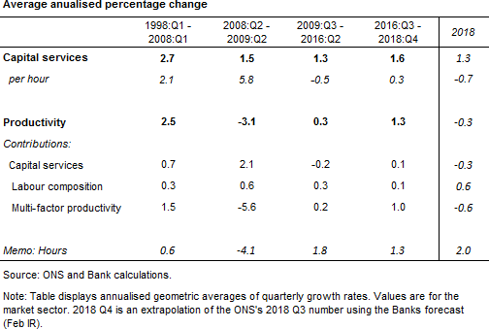

The last two lines in the middle section in **Table 3** show the contributions of labour services and multi-factor productivity to productivity growth. The contribution of labour services is, like capital, the growth in labour, adjusted for skills, multiplied by the labour share in output. As it shows, labour services have contributed to productivity reasonably steadily over the period, with the recession an exception (a period of upskilling in labour).

The line entitled “multi-factor productivity” growth is the residual. That comes from a number of sources. One is mismeasurement (since it is a residual) and the other is gains by firms over and above those from the capital and labour they pay for. Such gains are what economists call “spillovers”, and by definition come for

free. How does that occur? If Sainsbury’s build another shop, the gains do not spillover to Tesco since Tesco cannot use the shop. But if Sainsbury’s figure out that it can load goods more efficiently by tessellating boxes in its trucks, that is pretty easy to copy by Tesco. Such “knowledge” or “intangible” investment likely confers more spillovers then tangible investment. This means that multiplying the Intellectual Property Products (IPP, which includes R&D, software and databases, mineral exploration and evaluation, and entertainment, literary or artistic originals) part of capital services by a rate of return likely understates its contribution to productivity growth since it only gives the contribution of the business doing the investment and not the other businesses gaining the spillover benefit. There is, thus, potentially a connection between the IPP of capital services and TFP growth, see (Grilliches, 1992). It is interesting to note that this part of investment seems to have held up which portents well for future TFP growth if it can be maintained.

# “Brexit is a process not an event”: the future implications for business investment

The February 2019 *Inflation Report* (BoE, February Inflation Report, 2019) assumed “a smooth adjustment to new trading relations with the EU16. Consistent with that, uncertainties about Brexit are assumed to wane over the forecast period (p.9). As part of that transition, business investment is assumed to fall again in 2019, but then recover to be growing at rates of around 3% and 4% in 2020 and 2021 (Table 5E, February 2019 Inflation Report). That rebound is assumed to come about as uncertainty remains elevated but then wanes and so investment bounces back (in terms of contributions to GDP, business investment is projected to contribute negatively by a ¼pp to GDP in 2019 but then is expected to push up on GDP by ¼pp in 2020 and

½pp in 2021).

Box 5 in the *Inflation Report* illustrates the sensitivity of the MPC’s projections to where uncertainty (and tight financial conditions) remains elevated throughout the forecast period. In that case GDP growth was 0.8% in 2020 and 1.5% in 2021, which is materially lower then in the central forecast of 1.5% and 1.9%. Thus, the IR indicated this elevation of uncertainty as a material downside17 risk to the forecast. In this final section I want to explore these risks further.

As I speak to you today, Parliament is scheduled to vote on the EU Withdrawal Agreeement tomorrow. At the outset, I must stress that as an MPC member I have no, repeat no, view on whether the agreement is good or bad for the totality of political, economic and other factors in the UK. That is beyond the MPC’s remit.

What the MPC has to consider is how the agreement might affect its remit, the main part of which is price stability. As my colleagues have rightly stressed, this depends on the balance of supply, demand and the

16 The final trade arrangement is assumed to be an average of three different trading relationships: WTO, FTA and EEA.

17 This is not to say, however, that to simply remove uncertainty by any means would be a positive for economic output. An example would be if you exchanged an uncertain output outcome for a certain lower output outcome. For example in the Bank’s report to the Treasury Select Committee the ‘no deal, no transition’ scenario had GDP 4.75% to 7.75% percent lower by the end of 2024 compared to the forecast in the November *Inflation Report* (BoE, EU withdrawal scenarios and monetary and financial stability, 2018).

exchange rate and, as we have seen today, investment is an important part of that supply and demand picture. Currently, it looks like uncertainty is holding investment back. If that continues, then there is a downside risk to the forecast. So why might it continue? The reason comes from two points. First, investment decisions take time to pay back and hence investment might be held back by the prospect of uncertainty at some point in the payback period (for example as the (SMMT, 2018) has documented, in cars a payback period of 5-7 years is typical).

Second, to repeat, Sir Ivan Rogers’ observation that Brexit is a proces. To understand this point, it is worth setting out some idea of the process, the excellent recent book by (O'Rourke, 2019) surveys this, for example. The EU Withdrawal Agreement (as well as agreeing a divorce bill and citizen rights) agrees a “transitional” (or what is sometimes also called an “implementation”) period of 21 months to 4 years over which current trade arrangements will continue, after which the UK will trade under whatever new trade relationship is agreed18.

There are two aspects of this process that might give rise to heightened uncertainty.

First, the transition period is itself uncertain. Why? The Withdrawal Agreement specifies that the transition period is a minimum 21 months, during which trade is business-as-usual, but that there might an extension to 4 years. The EU summary document19 accompanying the Agreement sets out the process here:

*“The Withdrawal Agreement includes the possibility …to extend the transition period. This possibility can only be used once… by mutual agreement of the Union and the UK. All other terms agreed …will remain applicable [including] full powers of the Union institutions, including the Court of Justice. Extending the transition period will require a fair financial contribution from the UK to the EU budget”.*

It is conceivable that, like Article 50, the UK will require more time than the 21 months.20 Thus, it is possible there might be another round of negotiating and attendant uncertainty.

Second, to make long-term investments, an investor also needs also to know the future trade relationship that we strike. That is far from certain since, as O’Rourke points out, it is not covered in the Withdrawal Agreement. Rather one must look to the Political Declaration: however, that only contains the broadest words about wanting a close relationship. For business, the question of whether that is a customs union or free-trade area is vital since that gives more of a steer as to whether there will be relatively frictionless trade with the EU or not21. This has to be decided so that negotiators can get started and firms can, in turn, make

18 The EU website contains a handy FAQ and summary: [http://europa.eu/rapid/press-release_MEMO-18-6422_en.htm.](http://europa.eu/rapid/press-release_MEMO-18-6422_en.htm)

19 [http://europa.eu/rapid/press-release_MEMO-18-6422_en.htm.](http://europa.eu/rapid/press-release_MEMO-18-6422_en.htm)

20 For example, Japan’s recent free trade agreement with the EU came into force in February 2019 on the back of negotiations commenced in 2013 and finalised in December 2017 (EC, 2019).

21 O’Rourke describes the fundamental tensions here. A customs union, with a common external tariff is more amenable to a trade with less frictions, since fewer border checks are needed, but this then precludes bilateral deals with other countries which many feel to be an advantage.

investment plans. Furthermore, during the implementation period Parliament would likely need to pass a significant volume of domestic legislation, in addition to possibly having to ratify numerous trade agreements which include new trade deals, data sharing and security issues amongst many others22.

The longer term question is whether investment will eventually bounce back after uncertainty is resolved. The answer to this depends on what trade deal is struck. In the MPC’s forecast, the economy ends up (in 15 years) at the average of three trade deal outcomes all of which mean less trade and, therefore, a lower level of output (but the same growth rate). In standard growth models, a lower level of output means less capital (since the capital/output ratio is a constant) and hence investment does not bounce back fully since less capital is required. If there was a lower level of output and also lower long term growth, there would be even less bounce back. But all of this is a long way off. At least for the next few years the prospect of low investment seems possible.

22 The role of Parliament in trade agreements is a complicated one, since governments usually invoke the Royal Prerogative and regard the making, agreeing and withdrawing from trade agreements as a function of the executive. A recent Department for International Trade policy document.

# References

**BoE.** (2018). EU withdrawal scenarios and monetary and financial stability. available at [https://www.bankofengland.co.uk/report/2018/eu-withdrawal-scenarios-and-monetary-and-financial-stability,](https://www.bankofengland.co.uk/report/2018/eu-withdrawal-scenarios-and-monetary-and-financial-stability) Bank of England.

**BoE.** (2019). February Inflation Report. Bank of England: available at [https://www.bankofengland.co.uk/inflation-report/2019/february-2019.](https://www.bankofengland.co.uk/inflation-report/2019/february-2019)

**Broadbent, B.** (2014). The balance of growth. Speech given at London School of Economics on 17 January 2014.: available at [https://www.bankofengland.co.uk/speech/2014/the-balance-of-growth.](https://www.bankofengland.co.uk/speech/2014/the-balance-of-growth)

**Broadbent, B.** (2016). Uncertain times. Speech given at Wall Street Journal on 5th October 2017: available at [https://www.bankofengland.co.uk/-/media/boe/files/speech/2016/uncertain-times.](https://www.bankofengland.co.uk/-/media/boe/files/speech/2016/uncertain-times)

**Carney, M.** (2019). The Global Outlook. Speech given at Frobisher hall on 12th February 2019: available at [https://www.bankofengland.co.uk/speech/2019/mark-carney-speech.](https://www.bankofengland.co.uk/speech/2019/mark-carney-speech)

**Coyle, D.** (2015). GDP: A Brief but Affectionate History-Revised and expanded Edition. Princeton University Press.

**EC. (2019).** European Commission. Retrieved from [http://ec.europa.eu/trade/policy/in-focus/eu-japan-](http://ec.europa.eu/trade/policy/in-focus/eu-japan-economic-partnership-agreement/) [economic-partnership-agreement/](http://ec.europa.eu/trade/policy/in-focus/eu-japan-economic-partnership-agreement/)

**Grilliches, Z.** (1992). The Search for R&D Spillovers. Scandinavian Journal of Economics, S29-47.

**Haddow, A., Hare, C., Hooley, J., & Shakir, T.** (2013, Q2). Retrieved from Bank of England: https:/[/www.bankofengland.co.uk/quarte](http://www.bankofengland.co.uk/quarterly-bulletin/2013/q2/macroeconomic-uncertainty-what-is-it-how-can-)r[ly-bulletin/2013/q2/macroeconomic-uncertainty-what-is-it-how-can-](http://www.bankofengland.co.uk/quarterly-bulletin/2013/q2/macroeconomic-uncertainty-what-is-it-how-can-) we-measure-it-and-why-does-it-matter .

**Haskel, J., & Westlake, S.** (2018). Capitalism Withouth Capital. Oxford: Princeton University Press.

**Jorgenson, D., & Griliches, Z.** (1966). Sources of Measured Productivity Change: Capital Input. American Economic Review, 50-61.

**King, M.** (2016). The End of Alchemy: Money, Banking and the Future of the Global Economy. London: Little, Brown.

**Knight, F. H.** (1921). Risk, Uncertainty and Profit. Cornell University Library Digital Collections.

**McCafferty, I.** (2014). Achieving a sustainable recovery: where next for business investment? Speech given at Nottingham Business School on 22nd January 2014: available at [https://www.bankofengland.co.uk/-](https://www.bankofengland.co.uk/-/media/boe/files/speech/2014/achieving-a-sustainable-recovery-where-next-for-business-investment.pdf?la=en&hash=60B86C35D15C1CA5EBD0DB275299369A1F03FF97)

[/media/boe/files/speech/2014/achieving-a-sustainable-recovery-where-next-for-business-](https://www.bankofengland.co.uk/-/media/boe/files/speech/2014/achieving-a-sustainable-recovery-where-next-for-business-investment.pdf?la=en&hash=60B86C35D15C1CA5EBD0DB275299369A1F03FF97) [investment.pdf?la=en&hash=60B86C35D15C1CA5EBD0DB275299369A1F03FF97.](https://www.bankofengland.co.uk/-/media/boe/files/speech/2014/achieving-a-sustainable-recovery-where-next-for-business-investment.pdf?la=en&hash=60B86C35D15C1CA5EBD0DB275299369A1F03FF97)

**OECD.** (2014). Understanding National Accounts. OECD Paris: available at [http://www.oecd.org/sdd/UNA-](http://www.oecd.org/sdd/UNA-2014.pdf) [2014.pdf.](http://www.oecd.org/sdd/UNA-2014.pdf)

**ONS.** (2019). Developing experimental estimates of investment in intangible assets in the UK: 2016. Office of National Statistics.

**O'Rourke, K.** (2019). A Short History of Brexit: From Brentry to Backstop. London: Penguin Random House UK.

**Piketty, T.** (2014). Capital in the Twenty-First Century. Cambridge: Harvard University Press.

**Rogers, I.** (2018). Speech by Sir Ivan Rogers on Brexit. Heseltine Institute for Public Policy, Practice and Place: available at [https://news.liverpool.ac.uk/2018/12/13/full-speech-sir-ivan-rogers-on-brexit/.](https://news.liverpool.ac.uk/2018/12/13/full-speech-sir-ivan-rogers-on-brexit/)

**SMMT.** (2018). Automotive Priorities for the Brexit Transition. SMMT: available at: [https://www.smmt.co.uk/wp-content/uploads/sites/2/SMMT-Brexit-Position-Paper-UK-Automotive-Priorities-](https://www.smmt.co.uk/wp-content/uploads/sites/2/SMMT-Brexit-Position-Paper-UK-Automotive-Priorities-for-the-Brexit-Transition.pdf) [for-the-Brexit-Transition.pdf.](https://www.smmt.co.uk/wp-content/uploads/sites/2/SMMT-Brexit-Position-Paper-UK-Automotive-Priorities-for-the-Brexit-Transition.pdf)

**Vlieghe, G.** (2019). The Economic Outlook: Fading global tailwinds, intensifying Brexit headwinds. Speech given at Resolution Foundation on 14th February 2019: available at https:/[/www.bankofengland.co.uk/sp](http://www.bankofengland.co.uk/speech/2019/gertjan-vlieghe-speech-at-the-resolution-foundation)e[ech/2019/gertjan-vlieghe-speech-at-the-resolution-foundation.](http://www.bankofengland.co.uk/speech/2019/gertjan-vlieghe-speech-at-the-resolution-foundation)